Group No.
35
PUNE INSTITUTE OF COMPUTER TECHNOLOGY
Dhankawadi, Pune -43.

DEPARTMENT OF ELECTRONICS & TELECOMMUNICATION ENGINEERING (E&TCE)
A
SYNOPSIS
ON
ContextMesh
Project by

Project Group Members:
Roll No | Name | Preferred Guides
42216 | SAHU ARYAN HEMANT KUMAR | Ms. P. B. Tathe
42219 | Sonigara Moksh Sandeep | Dr. M. P. Turuk
42202 | Asolekar Raman Moreshwar | Dr. S. S. Vasekar

TITTLE:-
To Test and implement Cartesian Co-ordinate system for automatic x-y position finding.
AIM OF PROJECT:-

- TITLE: -sheet music generator played by piano

- AIM OF PROJECT: -To synthesize and share AI coding session context across team members in real time, enabling every developer's AI assistant to start each session already informed about the team's decisions, in-progress work, and open questions.

- INTRODUCTION :-
The ContextMesh system consists of a lightweight MCP server installed on each developer's machine that captures AI coding sessions and routes them to a shared backend. The captured sessions are processed and a background synthesis engine uses an LLM to generate a structured master context document representing the team's collective knowledge. As the user codes with their AI assistant, the session is automatically saved to the team's shared memory at the end of each session.
The system operates as follows. The developer installs the ContextMesh CLI via npm and runs the setup wizard which prompts them for a team passcode and their name. Once authenticated, the CLI auto-injects itself into supported AI IDEs such as Claude and Cursor as an MCP server. From that point, the developer's AI assistant has access to five tools — start session, save context, get master context, load peer context, and mark private. When the developer finishes a coding session, their AI assistant calls save context which sends the conversation history and modified files to the FastAPI backend. Every 30 minutes a scheduler runs a synthesis job that feeds all recent team sessions into Google Gemini and produces a master context containing decisions made, tasks in progress, open questions, and detected conflicts. The next time any teammate starts a session, their AI assistant automatically loads this master context and begins informed.
HARDWARE &SOFTWARE REQUIRMENTS:-
- SOFTWARE REQUIRED:-
- Python 3.10+ with FastAPI and Uvicorn
- Node.js 18+ with npm
- PostgreSQL with pgvector extension
- Redis
- Supabase (authentication)
- Google Gemini API (gemini-2.5-flash, text-embedding-004)
- React + Vite + TypeScript (dashboard)
- MCP SDK (@modelcontextprotocol/sdk)

- BLOCK DIAGRAM OF PROJECT :-
x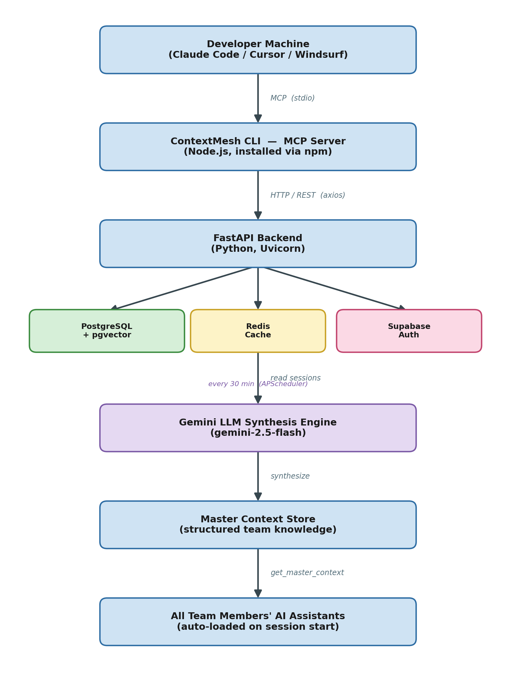
- DESCRIPTION OF BLOCK DIAGRAM :-

- Developer Machine / AI IDE: - The developer uses an AI coding assistant such as Claude Code, Cursor, or Windsurf on their local machine. This is the entry point where coding sessions are initiated and context is consumed.
- ContextMesh CLI (MCP Server): - A Node.js process installed via npm that runs locally on each developer's machine. It implements the Model Context Protocol over stdio, exposing five tools to the AI assistant: start_session, save_context, get_master_context, load_peer_context, and mark_private.
- FastAPI Backend: - A Python REST API server built with FastAPI and Uvicorn. It handles authentication, session storage, embedding generation, and orchestrates the synthesis pipeline. Runs on port 8000.
- PostgreSQL + pgvector: - Stores all session records, team memberships, master context versions, and 768-dimensional vector embeddings for semantic search across team sessions.
- Redis Cache: - Caches the synthesized master context for 35 minutes to reduce latency on repeated reads by team members.
- Gemini LLM Synthesis Engine: - Google Gemini (gemini-2.5-flash) reads all non-private team sessions from the past 7 days and synthesizes a structured master context containing decisions made, tasks in progress, open questions, and detected conflicts. It runs every 30 minutes via an APScheduler background job.
- Master Context Store: - The versioned output of the synthesis engine, stored in the database. Each synthesis run increments the version. It is served to any team member's AI assistant through the get_master_context MCP tool so every new session begins already informed.

- STEP- WISE EXECUTION:-

STEP 1  (July) | - Finalization of project domain and project Topic.  - Design of system architecture and block diagram (CLI → MCP → Backend → Gemini → Master Context)  - Plan for project execution and team roles
STEP 2  (August) | - Study of MCP (Model Context Protocol), FastAPI, and Supabase auth  - Preparation of Synopsis and Pre-project seminar.  - Design of final database schema (sessions, teams, members, master context, embeddings)
STEP 3  (September) | - Study of LLM synthesis, pgvector, and embedding models  - Setup of development environment — Python backend, Node CLI, Supabase, Redis  - First Assessment submission.
STEP 4  (October) | - Study of MCP server-client integration with Claude and Cursor IDEs  - Implementation of CLI setup flow, passcode auth, and JWT middleware  - Preparation & submission of seminar report.
STEP 5  (December) | - Testing and implementation of core save/synthesize/load context flow  - Integration of Gemini synthesis and pgvector semantic search  - First end-to-end test with real team members
STEP 6  (Jan-Feb) | - Completion of React dashboard (hub) — member view, master context, usage stats  - Deployment of backend to cloud, CLI published to npm.
STEP 7  (Feb-March) | - Submission of second Assessment.  - Testing with real team — multi-member context saving, synthesis verification, conflict detection
STEP 8  (April) | - Preparation and writing of final project report.  - Checking and Printing of project report.
STEP 9  (May) | - Submission of final project report.

- REFERENCES:-
- 1. A Memory Fabric for Conversational AI Agents Enabling Shared and Persistent Multiuser Memory
https://link.springer.com/article/10.1007/s44163-026-00992-z

- 2. Zep: A Temporal Knowledge Graph Architecture for Agent Memory (Graphiti)
https://arxiv.org/abs/2501.13956

- 3. PROJECTMEM: A Local-First, Event-Sourced Memory and Judgment Layer for AI Coding Agents
https://arxiv.org/abs/2606.12329

- 4. Cost and Accuracy of Long-Term Memory in Distributed Multi-Agent Systems (Mem0 vs Graphiti)
https://arxiv.org/abs/2601.07978

- 5. Evaluating Scoring Bias in LLM-as-a-Judge (prompt quality scoring)
https://arxiv.org/abs/2506.22316

